**Ideation Phase**

**Define the Problem Statements**

|  |  |
| --- | --- |
| Date | 19 September 2022 |
| Team ID | PNT2022TMID09881 |
| Project Name | Project - A Novel Method for Handwritten Digit Recognition System |
| Maximum Marks | 2 Marks |

**Customer Problem Statement Template:**

Create a problem statement to understand your customer's point of view. The Customer Problem Statement template helps you focus on what matters to create experiences people will love.

A well-articulated customer problem statement allows you and your team to find the ideal solution for the challenges your customers face. Throughout the process, you’ll also be able to empathize with your customers, which helps you better understand how they perceive your product or service.

**PROBLEM STATEMENT 1:**

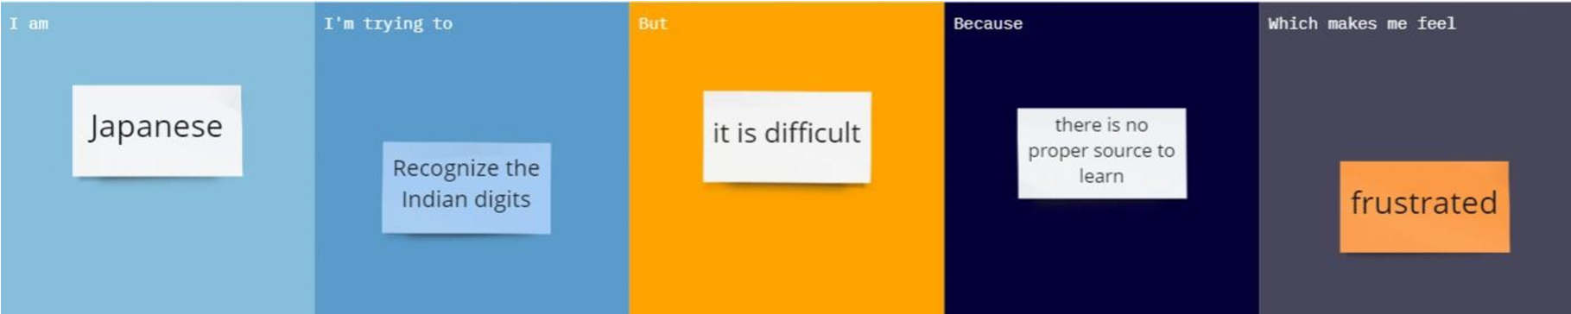

**PROBLEM STATEMENT 2**:

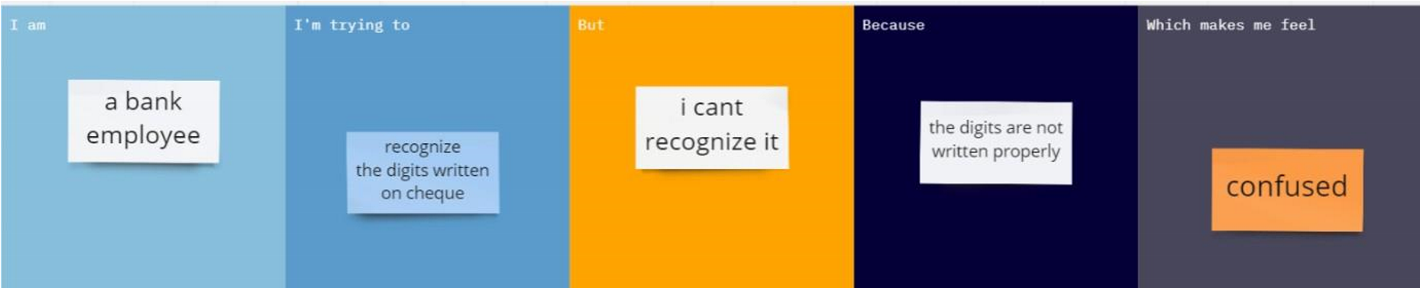

**PROBLEM STATEMENT 3**:

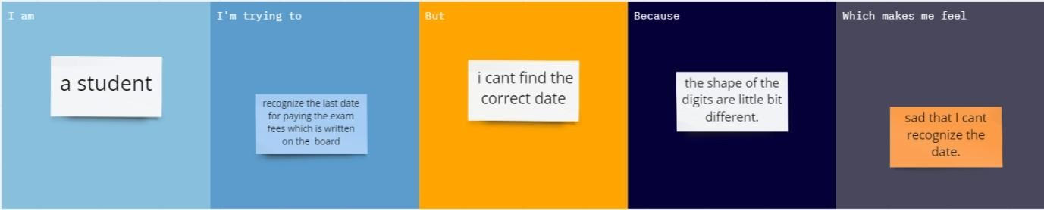

**PROBLEM STATEMENT 4**: 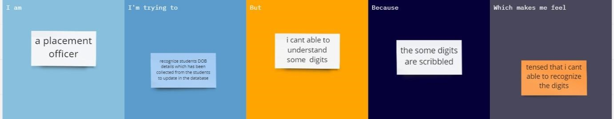

|  |  |  |  |  |  |
| --- | --- | --- | --- | --- | --- |
| **Problem**  **Statement (PS)** | **Iam**  **(Customer)** | **I’m trying to** | **But** | **Because** | **Which makes me feel** |
| PS-1 | Japanese | Recognize the Indian digits | It is difficult | There is no proper source to learn | Frustrated |
| PS-2 | A bank employee | Recognize the digit written on cheque | I can’t recognize  it | The digits are not written properly | Confused |
| PS-3 | A student | recognize the last date for paying the exam fees which is written on the board | I can’t find the correct date | The shapes of the digits are a little bit different. | Sad that I can’t recognize the date |
| PS-4 | a  placement officer | recognize students’ DOB details which have been collected from the students to update the database | I can’t able to understand some digits | Some digits are scribbled | Tensed that I can’t able to recognize the digits |